Monitoring Type: Formal Monitoring

Night Survey #: 2 Outing #: 1 Survey Aborted? N Survey Completed? Y % Survey Area Covered: 100

Sunrise or Sunset Time: 1927

UTMs of New or Intermediate Call Points or Routes (not already mapped):
Call point name | UTME | UTMN |  | Call point name | UTME | UTMN
RIGGS3 | 596804 | 3620259
RIGGS2 | 597278 | 3619461
RIGGS1 | 596907 | 3618629
Moon phase: 1/4
TIME (24hrs) | Start | End | Total (~ ¼ hr)

Hike-in
Survey | 1933 | 2039 | 1.0

Hike-out
CP or RT # | CM | SM | Time Start | Time End | Total Time | Moon visible? | Wind (mph) | CC % | PPT ? | Temp (◦F) | Obs. Type | Sex | Age | SPP | Time of response | Bearing  (◦) | Distance (m) | UTM E  of owl  (estimated) | UTM N  of owl  (estimated)
RIGGS3 | 2 | 2 | 1933 | 1948 | 15 | Y | 0-12 | 0 | 0 | 64 | N
RIGGS2 | 2 | 2 | 1952 | 2007 | 15 | Y | 0-10 | 0 | 0 | 62 | N
RIGGS1 | 2 | 2 | 2024 | 2039 | 15 | Y | 10-15 | 0 | 0 | 62 | N
CM (Call Method): 1 = tape recording, 2 = vocalization, 3= combination, 4 = owl “hooter”; 5= not hooting SM (Survey Method): 1 = leap frog, 2 = point calling, 3=continuous calling; 4= not hooting Wind = range in mph; CC= cloud cover, PPT= precipitation (Y or N), Temp = ambient temperature; Obs. Type = aural (A), visual (V) detection, or put (N) for no response. SPP = 4 letter species code based on Latin name; Mex. Spotted Owl = STOC; Great Horned Owl = BUVI; Long-eared Owl = ASOT; Flammulated Owl = OTFL; Whiskered Screech Owl = OTTR; Western Screech Owl = OTKE; Elf Owl = MIWH; Northern Pygmy Owl = GLGN.

Brief Notes:

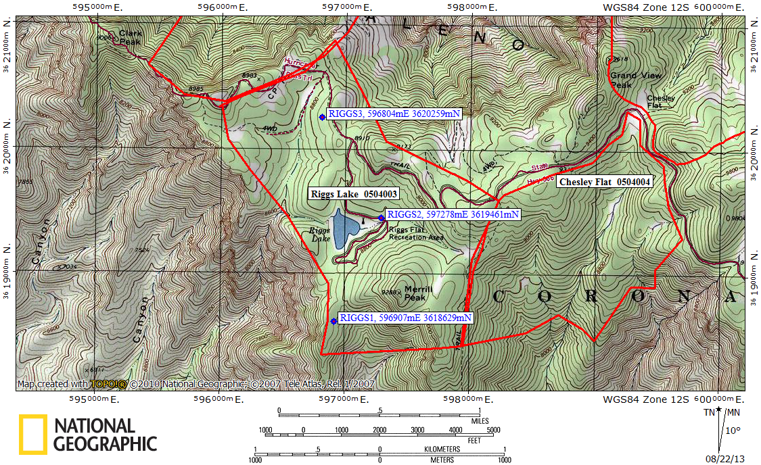
Red lines = PAC boundaries, waypoints = call points

